CASE #001

Rhinovore Case _ USB image

Brandon Bauder

12/13/2023

[bbauder1@student.rccd.edu](mailto:bbauder1@student.rccd.edu)

**TABLE OF CONTENTS**

Page 1: Cover Page

Page 2: Table of Contents

Page 3: Case Summary

Page 3 - 4: Evidence

Page 5: Objectives

Page 5: Forensic Analysis

Page 6: Relevant Findings

Page 6: Conclusion

Page 7 – 17: Exhibit

**CASE SUMMARY**

On December 6th 2023, an assignment was given to the students of the CIS27A class to analyze a dd file and three different network traffic files. The dd file in question is an image file of an USB that may contain images of rhinos. The network traffic may also contain evidence of rhinos as well. The task given by Professor Nguyen is to find at least nine images of rhinos.

**EVIDENCE**

* Screenshot 1: 1 Image of Rhino (image f0105848.jpg) Found on Autopsy (Windows). Rhino in plains at an angle facing camera
* Screenshot 2: 1 Image of 2 Rhinos (imagef0105864.jpg) Found on Autopsy (Windows). 2 Rhinos by water source. 1 Adult rhino, 1 child rhino.
* Screenshot 3: 1 GIF of Rhino (image f0106320.gif) Found on Found on Autopsy (Windows). Black and white drawing of a Rhino side view.
* Screenshot 4: 1 GIF of Rhino (image f0106344.gif) Found on Autopsy (Windows). 1 Cartoon image of a rhino full side view.
* Screenshot 5: 1 Image of Rhino (rhino4.jpg) Found on Wireshark (Kali Linux). 1 painted image of a rhino coming out of a vine
* Screenshot 6: 1 Image of Rhino (rhino5.gif) Found on Wireshark (Kali Linux). A drawn image of a rhino. Drawn with pencil. Rhino side view.
* Screenshot 7: 1 Screenshot of website being obtained from network. Website contains links and downloads to rhino3d tutorials. Found in Wireshark (Kali Linux)
* Screenshot 8: 1 Screenshot of website being obtained from network. Same Website as before. Now is highlighted to see text and links to download “Rhino.exe” Found in Wireshark (Kali Linux)
* Screenshot 9: 1 screenshot of TCP stream showing communications of Rhino3.jpg being downloaded from gnome server. Found on Wireshark (Kali Linux)
* Screenshot 10: 1 screenshot of TCP stream showing communications of Rhino1.jpg being downloaded from gnome server. Found on Wireshark (Kali Linux)
* Screenshot 11: 1 screenshot of TCP stream showing communications of contraband.zip (which contains rhino2.jpg) being downloaded from gnome server. Found on Wireshark (Kali Linux)
* Screenshot 12: 1 screenshot of FTP-data. Shows download data of rhino3.jpg that was downloaded from gnome server. Found on Wireshark (Kali Linux)
* Screenshot 13: 1 screenshot of FTP-data. Shows download data of rhino1.jpg that was downloaded from gnome server. Found on Wireshark (Kali Linux)
* Screenshot 14: 1 screenshot of FTP-data. Shows download data of contraband.zip that was downloaded from gnome server. Found on Wireshark (Kali Linux)
* Screenshot 15: 1 screenshot of TCP stream showing user accessing gnome and attempting to change the password. The password change was denied. Found on Wireshark (Kali Linux)
* Screenshot 16: 1 screenshot of HTML page of the user’s email. Receiving an email from [hugerhinolover@hotmail.com](mailto:hugerhinolover@hotmail.com) and sent to [bighonkingrhino@hotmail.com](mailto:bighonkingrhino@hotmail.com) on Monday, April 26, 2004, 10:23 PM. Found on Wireshark (Kali Linux)
* Screenshot 17: 1 screenshot of user’s Diary. Important line at the bottom before dotted line. Explains that “Things are getting a little weird” Explains that the hard drive was “zapped” and thrown into the Mississippi River and the USB drive will be reformatted. Found in Kali Linux by using Scalpel to extract document.
* Screenshot 18: 1 screenshot of second half of Diary. Explains that the password on gnome will be changed and it was “Jeremy” that gave the user the gnome account.
* Screenshot 19: 1 screenshot of contraband.zip that contains rhino2.jpg. Downloaded from Wireshark (Kali Linux)
* Screenshot 20: 1 screenshot of rhino3.jpg . Downloaded from Wireshark (Kali Linux)
* Screenshot 21: 1 screenshot of rhino1.jpg . Downloaded from Wireshark (Kali Linux)

**OBJECTIVES**

The objectives of the case was to analyze the image file of the USB and the three Network traffic files to see if the user has illegally downloaded images of rhinos. The goal is to find at least nine instances Rhino images. The goal is also to find out who gave the user the gnome account, what the gnome account user name and password was, what relevant file transfers were there, what relevant files were on the USB, and what happened to the Computer Hard Drive and USB.

**FORENSIC ANALYSIS**

1. 12-06-2023: Today was focused on what could be found on the USB image file using Autopsy via the Windows 11 device. I created a report and was able to extract files from the USB. From the initial analysis, the following documents were discovered: 2 recipes for gumbo, 2 documents containing the repeating words of “SORRY” and “CHARLIE”, and one Diary of the user **(Screenshot 17, Screenshot 18)** *NOTE: Screenshot 17 and 18 were taken via Kali Linux using the Scalpel tool. The document in both Autopsy in Windows and Kali Linux contain the same relevant information. In addition to these documents, 4 images of rhinos were found **(Screenshot 1, Screenshot 2, Screenshot 3, Screenshot 4)**.
2. 12-12-2023: Investigations resumed using Kali Linux. Today’s investigation will focus on using Wireshark to analyze the user’s network traffic. Traces of downloaded images of rhinos were found in packet number 34 in log rhino2.log. The log shows evidence of rhino4 and rhino5 being downloaded. Then the two logs that show rhino4 and rhino5 were found. Log rhino2.log shows in packet number 215, a TCP protocol has the image of rhino4.jpg, which was downloaded on Wed April 28th 2004 at 21:07:28 GMT **(Screenshot 5)**. Log rhino2.log also shows in packet number 312, a TCP protocol has the image of rhino5.gif, which was downloaded on Wed April 28th 2004 at 21:07:34 GMT **(Screenshot 6)**. Continuing the investigation into the log rhino3.log shows that the user visited a website that contains a download link to a file called “Rhino.exe”, which was on packet 110 of rhino3.log **(Screenshot 7, Screenshot 8)**. Further investigation showed evidence of the user requesting and downloading three relevant items, that being rhino1.jpg, rhino3.jpg, and contraband.zip, all of these were found in rhino.log on packet lines: 1605, 1732, and 5832**(Screenshot 9, Screenshot 10, Screenshot 11, Screenshot 12, Screenshot 13, Screenshot 14)**. In log file rhino.log, on packet 1316, there was evidence of the user attempting to change the password of the gnome account, but was denied. This is relevant as the diary entry mentions changing the password to the account given to the user **(Screenshot 15)**. The last piece of important evidence of the day’s investigation was a html page showing an email page. The email page may belong to the user going under the email name of “[bighonkingrhino@hotmail.com](mailto:bighonkingrhino@hotmail.com)”. The email contains the message that more rhino pictures were added to the gnome account: “I just checked a few things on the gnome account on cook.cs.uno.edu. I’m about to upload some new rhino stuff. Check it out. -John”. **(Screenshot 16)**.

**RELEVANT FINDINGS**

The findings of the investigation shows that the suspect has downloaded at least nine separate photos of rhinos. **Screenshot 1, Screenshot 2, Screenshot 3, Screenshot 4** where found in the USB image file meaning the suspect, to start, has at least 4 images of rhinos in possession. **Screenshot 4,** and **Screenshot 5** shows that the suspect has downloaded 2 more images of rhinos, making the total count of rhinos to 6. **Screenshot 12, Screenshot 13, Screenshot 14** shows three additional rhinos where downloaded. However, **Screenshot 13** only shows a zip file being downloaded, but **Screenshot 19** shows the contents of the zip file is rhino2.jpg, which makes the total count, including the other two downloads, 9 images of rhinos. The bare minimum amount of rhino pictures needed to be found was 9, which is the total found during the investigation.

The file carving process shows a dairy document found on the USB, which is seen in **Screenshot 17** and **Screenshot 18.** The important part is at the end where the suspect claims the following: the hard drive containing the contraband was “zapped” and thrown into the Mississippi River, the USB was reformatted, and the person who gave the suspect the gnome account, the account containing the rhino pictures, was from a person named “Jeremy”. Additionally, the suspect plans to change password to the gnome account, which is shown in **Screenshot 15**. This is important to note as this can be used to connect the suspect to the account. The user name and password for the gnome account containing the rhino pictures is the user name of “gnome” and the password of “gnome123”. This is seen in requests of **Screenshot 9, Screenshot 10,** and **Screenshot 11**.

**CONCLUSION**

From what the investigation has shown, I believe the suspect has enough evidence against them in a court of law. The suspect has shown that they have downloaded at least nine different images of rhinos which goes against the newly created law. There is evidence that the suspect had contributors in dealings with the person named “Jeremy”. There is evidence that the suspect tried to hide evidence by planning to wipe and hide the hard drive containing the illegal items and tried to hide evidence in the USB by reformatting it. Overall, the suspect has plenty of evidence to show that they have broken the law.

**EXHIBIT**

**Screenshot 1:** Screenshot 2023-12-06 183621_Rhino1.png

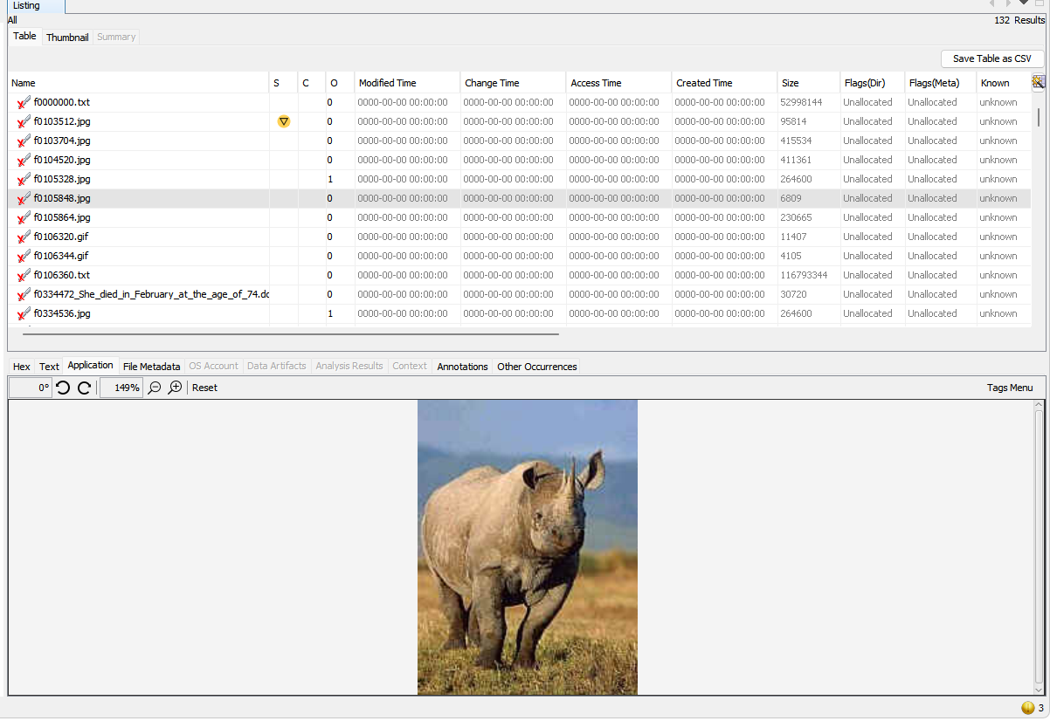

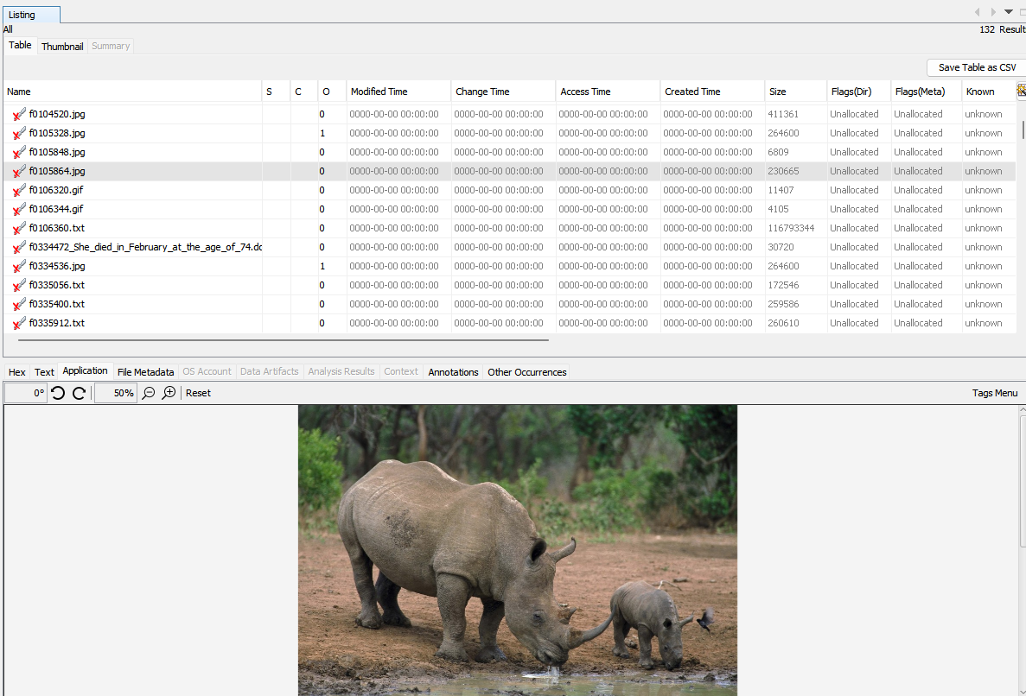 **Screenshot 2:** Screenshot 2023-12-06 183917_Rhino2.png

**Screenshot 3:** Screenshot 2023-12-06 184119_Rhino3.png

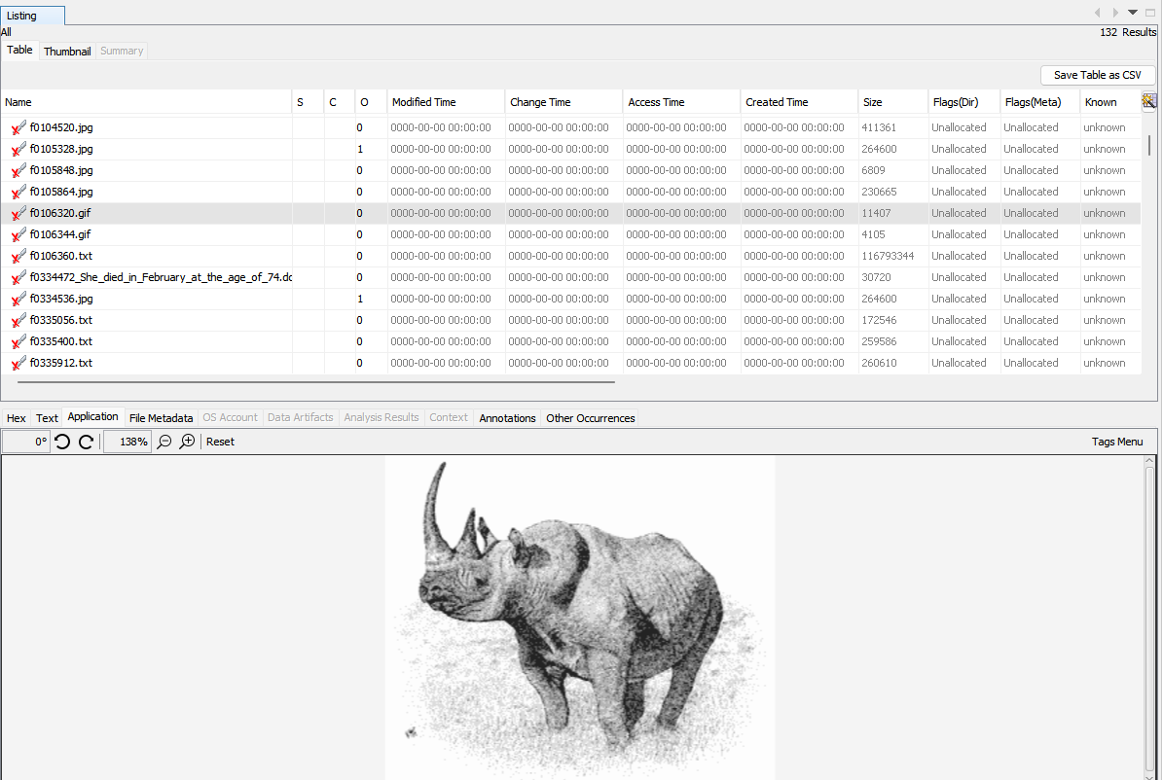

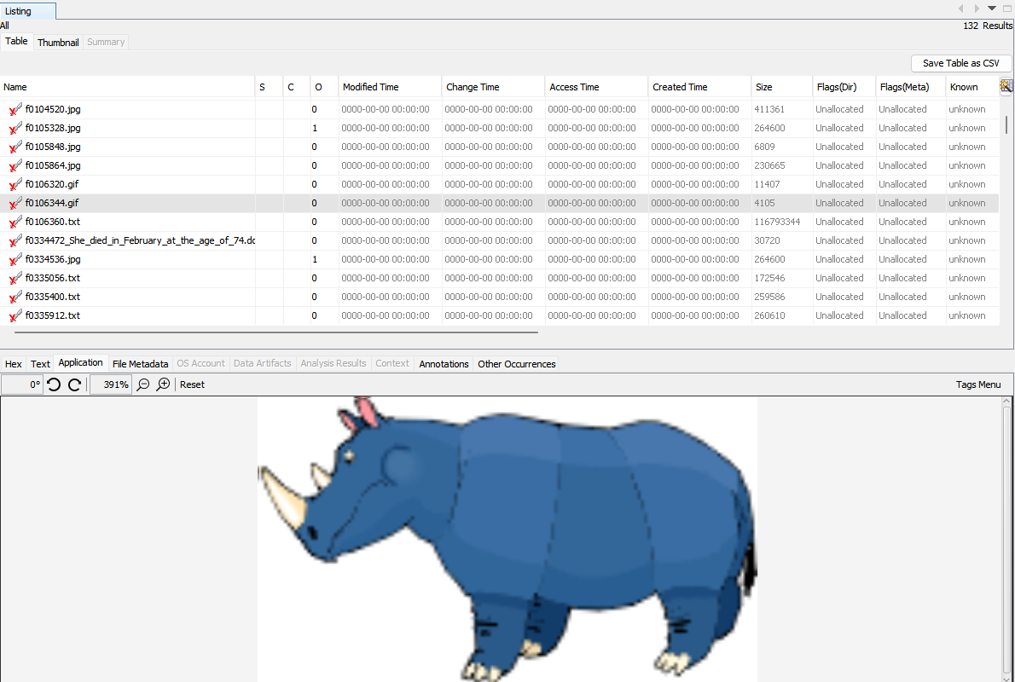**Screenshot 4:** Screenshot 2023-12-06 184423.png

**Screenshot 5:** Screenshot from 2023-12-12 12-07-13.png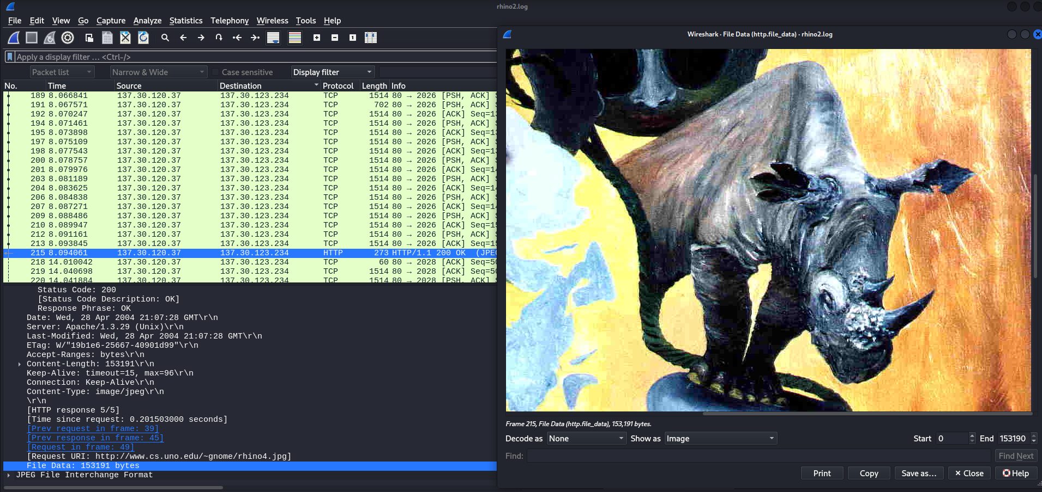

**Screenshot 6:** Screenshot from 2023-12-12 12-09-44.png

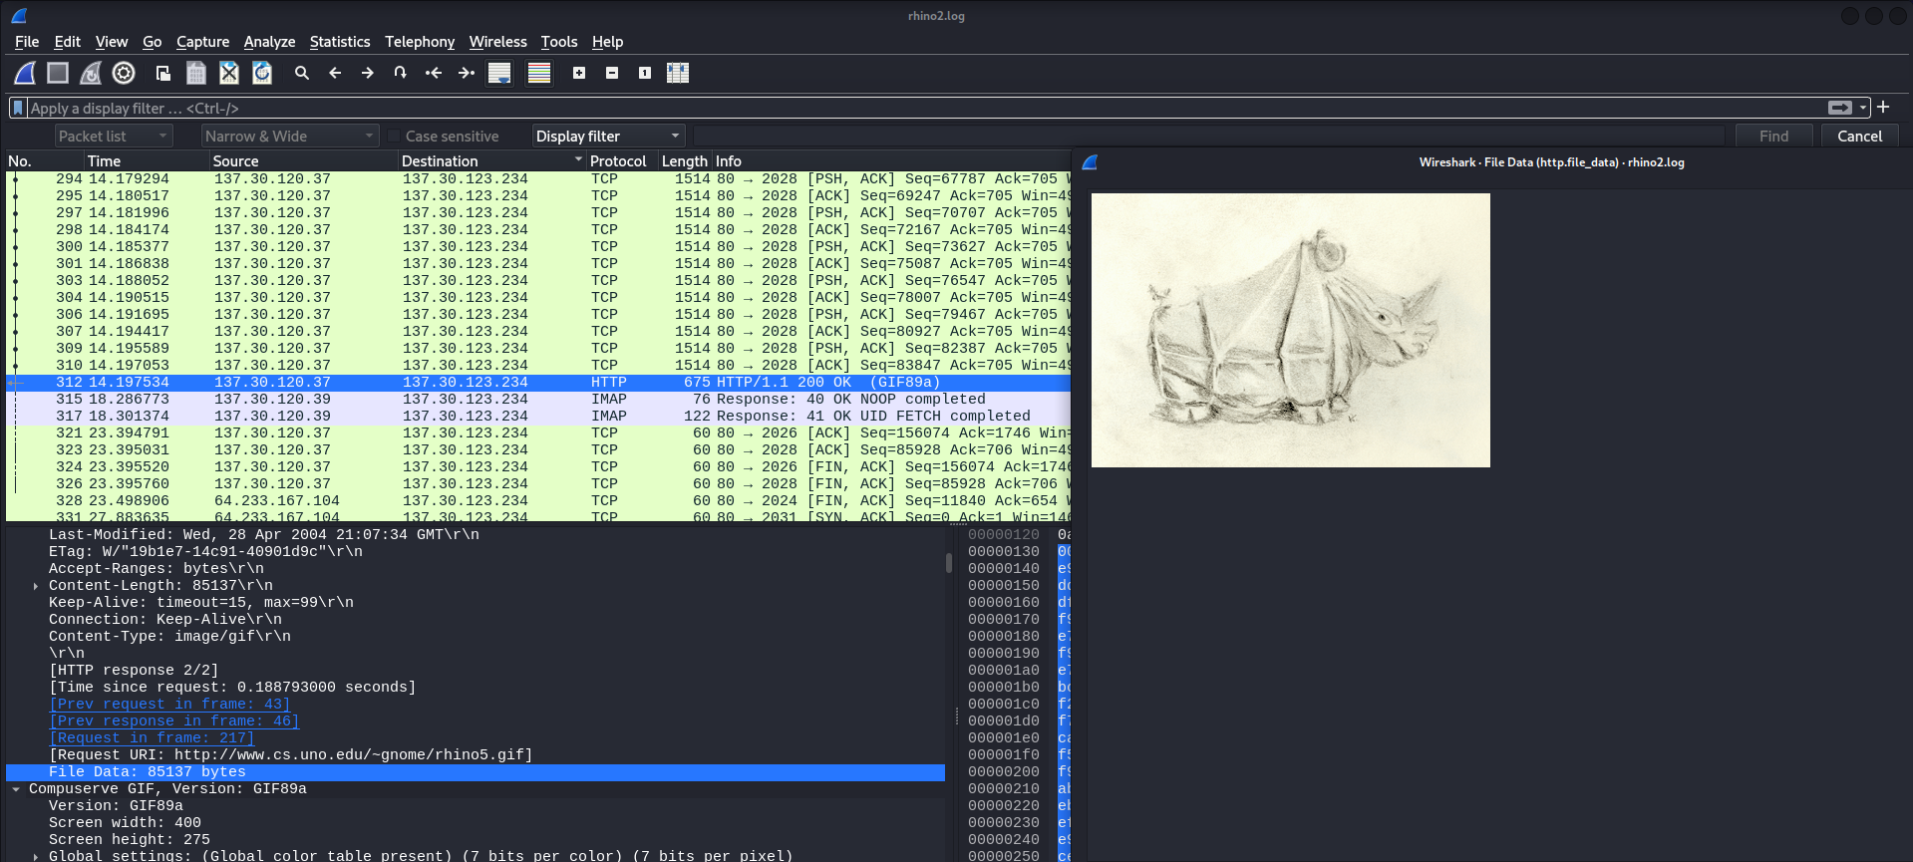

**Screenshot 7:** Screenshot from 2023-12-12 12-23-24.png

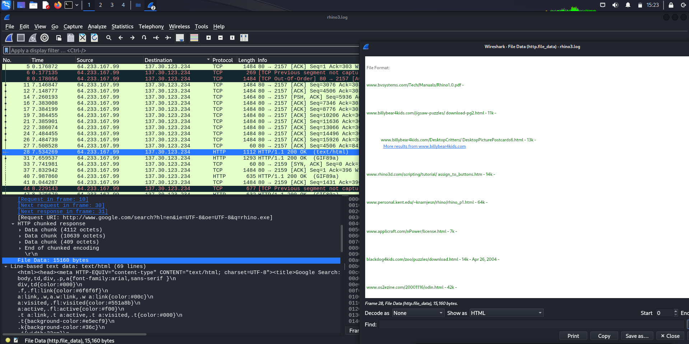

**Screenshot 8:** Screenshot from 2023-12-12 12-25-44.png

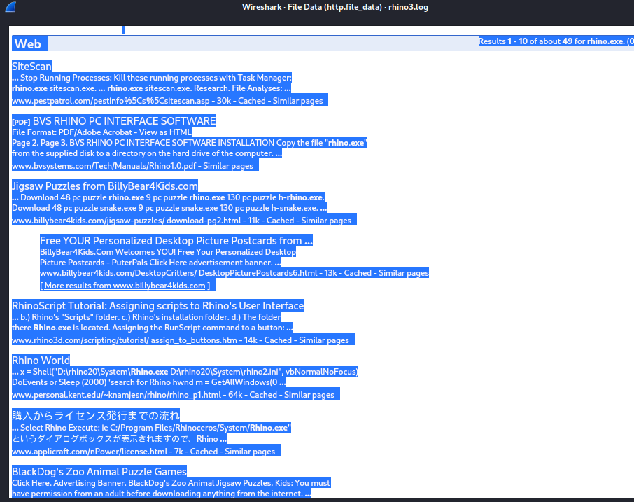

**Screenshot 9:** Screenshot from 2023-12-12 13-03-08.png

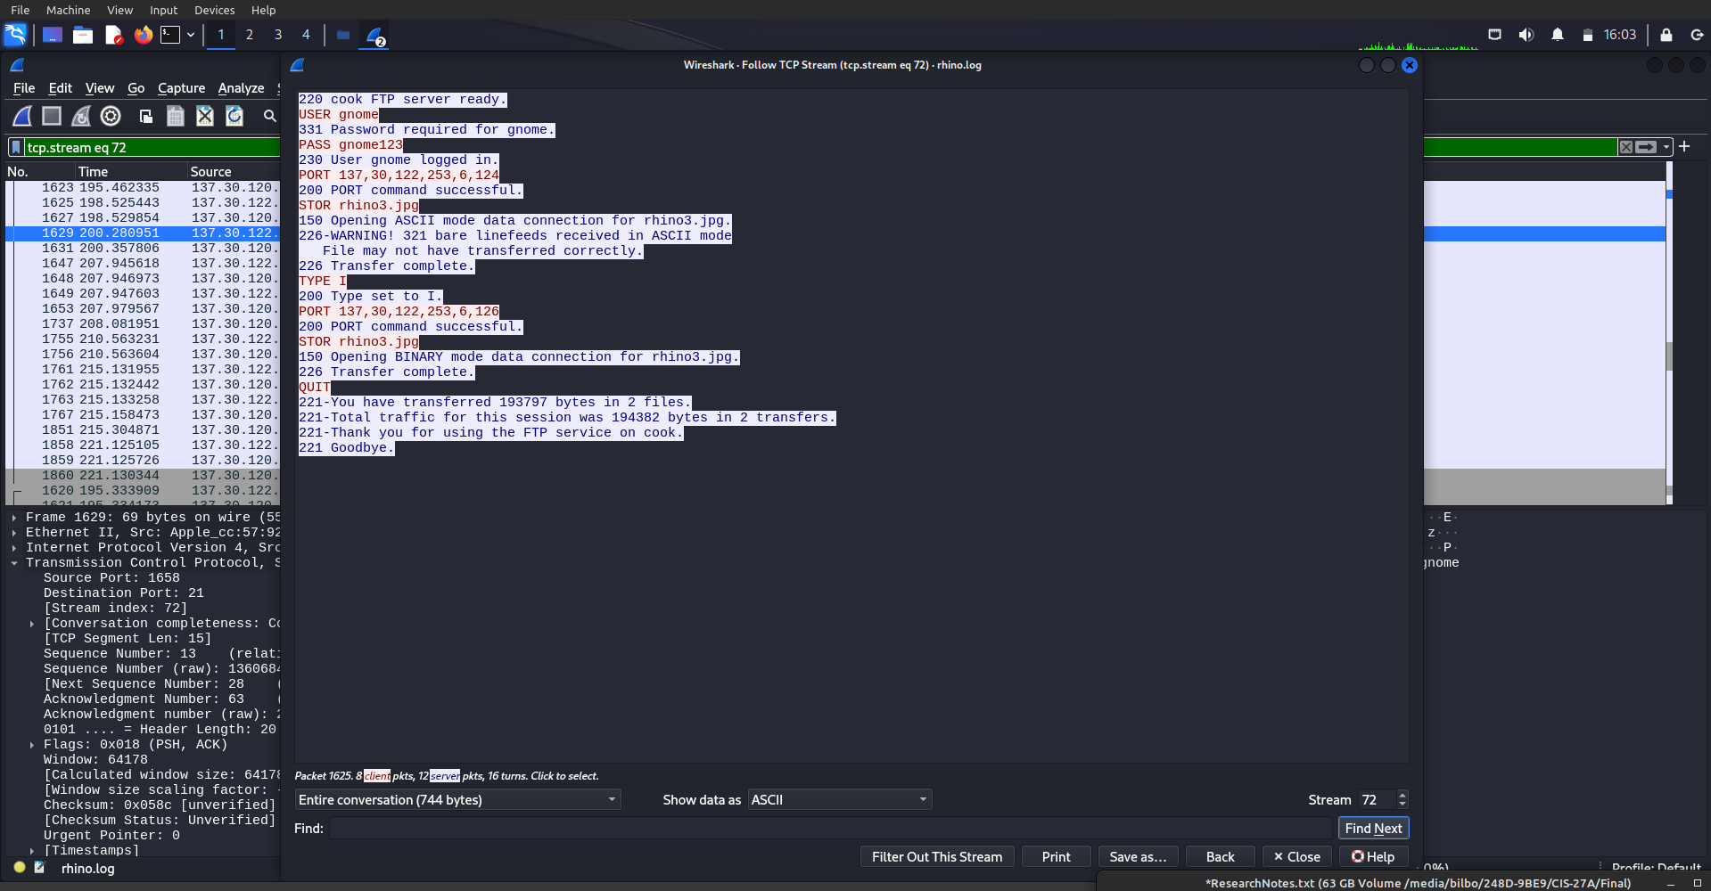

**Screenshot 10:** Screenshot from 2023-12-12 13-06-14.png

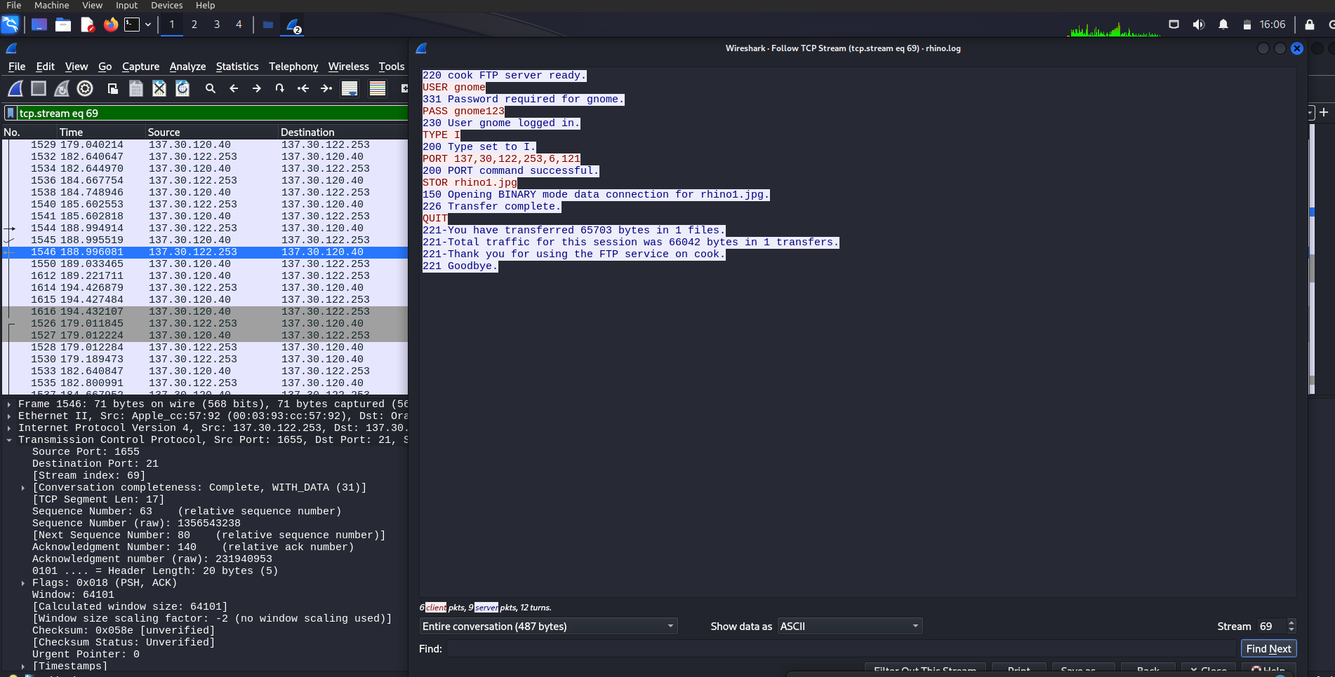

**Screenshot 11:** Screenshot from 2023-12-12 13-07-03.png

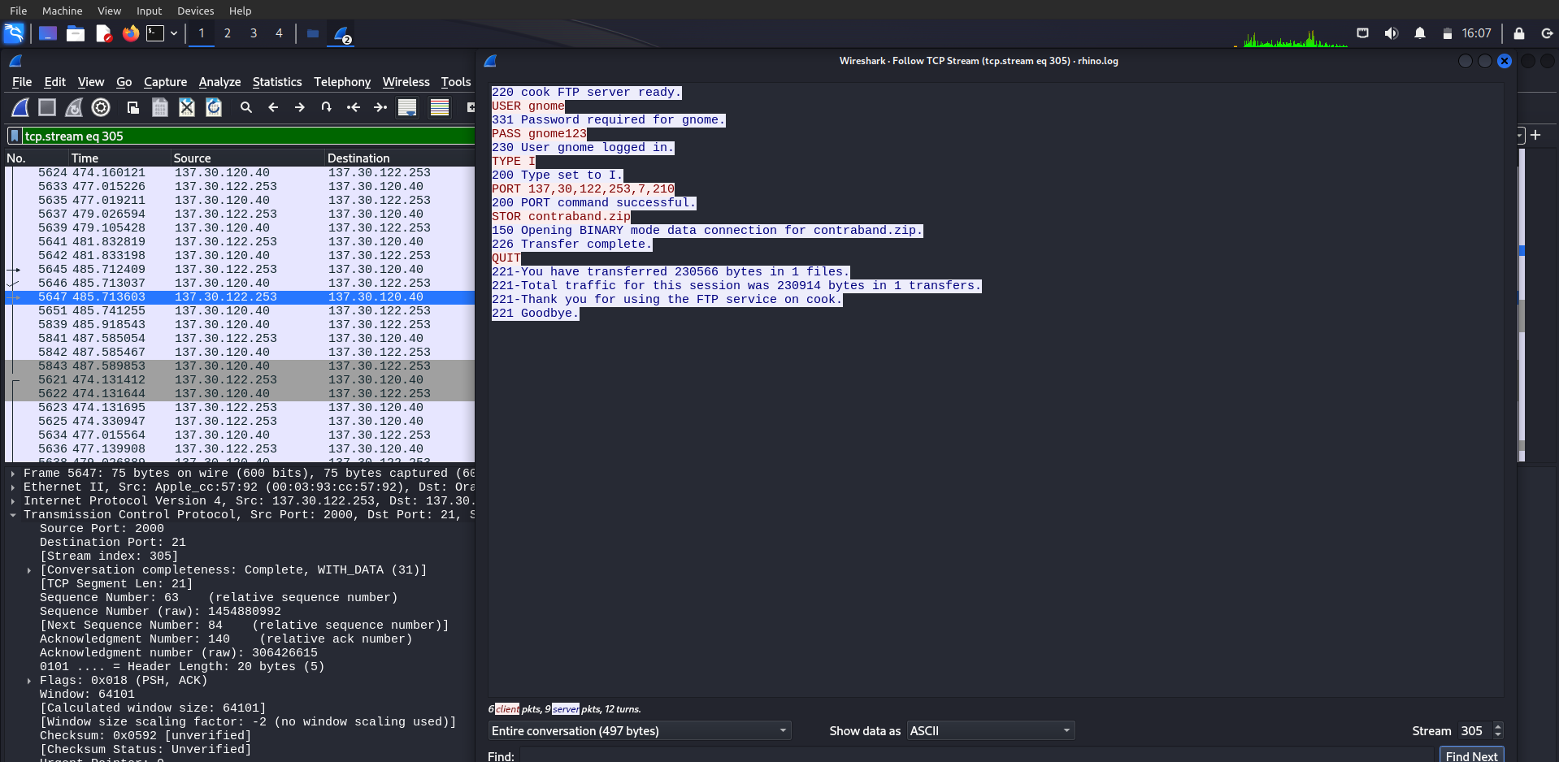

**Screenshot 12:** Screenshot from 2023-12-12 13-27-33.png

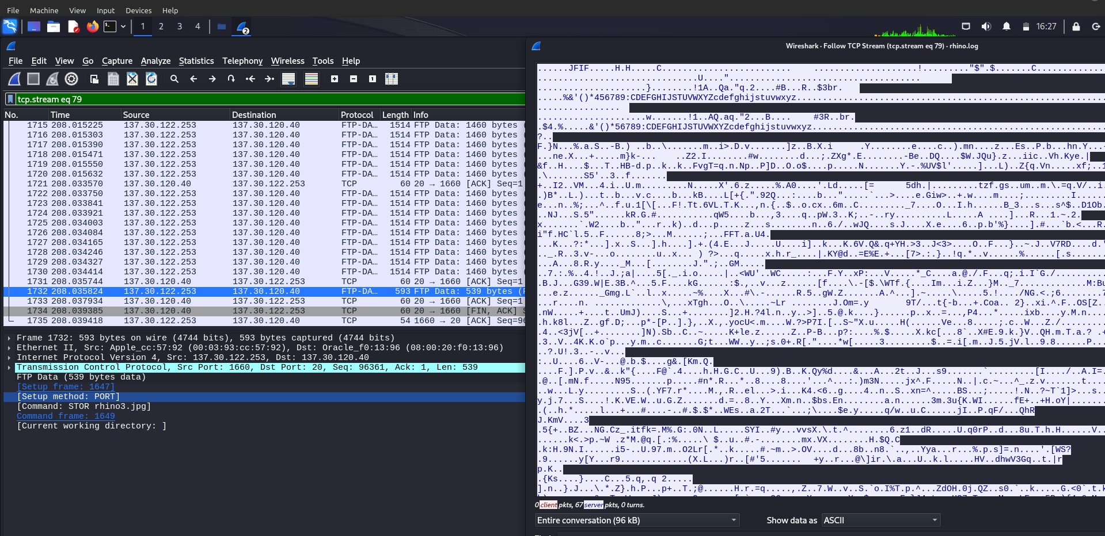

**Screenshot 13:** Screenshot from 2023-12-12 13-30-03.png

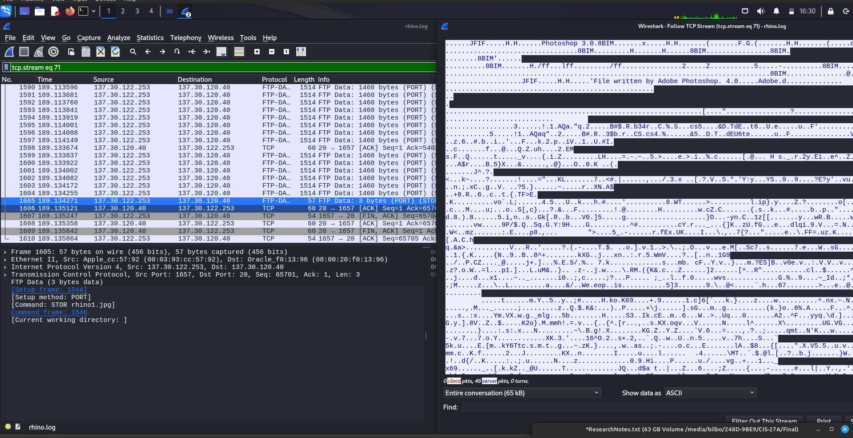

**Screenshot 14:** Screenshot from 2023-12-12 13-32-50.png

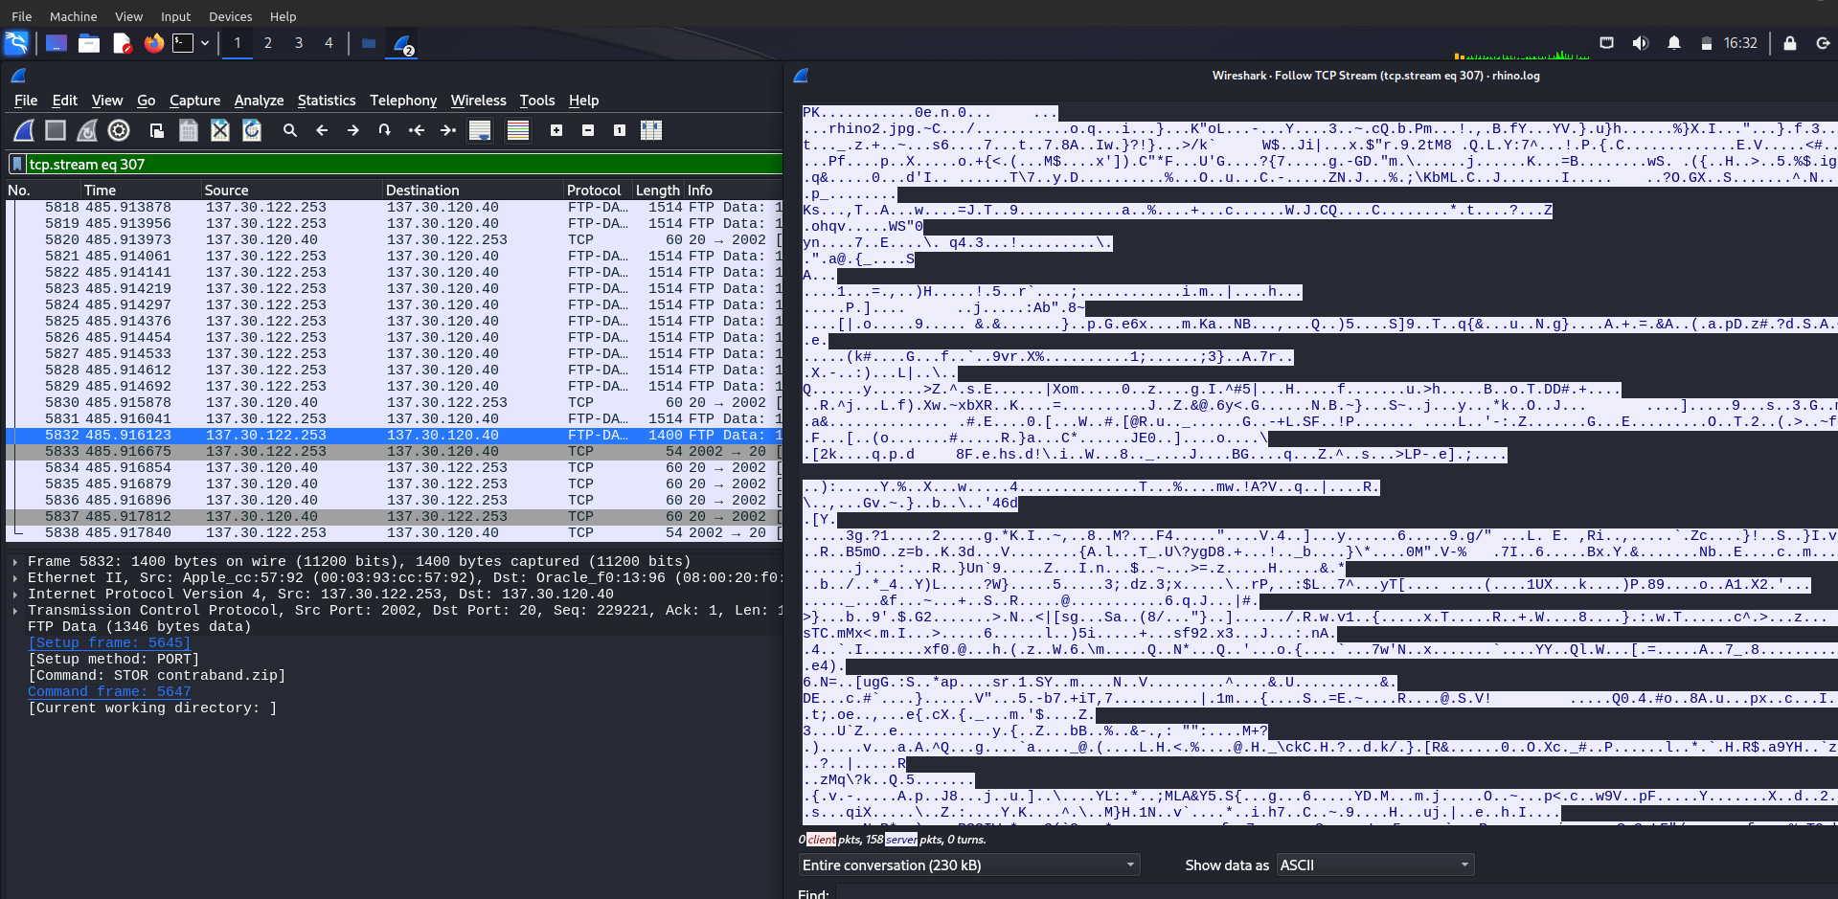

**Screenshot 15:** Screenshot from 2023-12-12 14-16-45.png

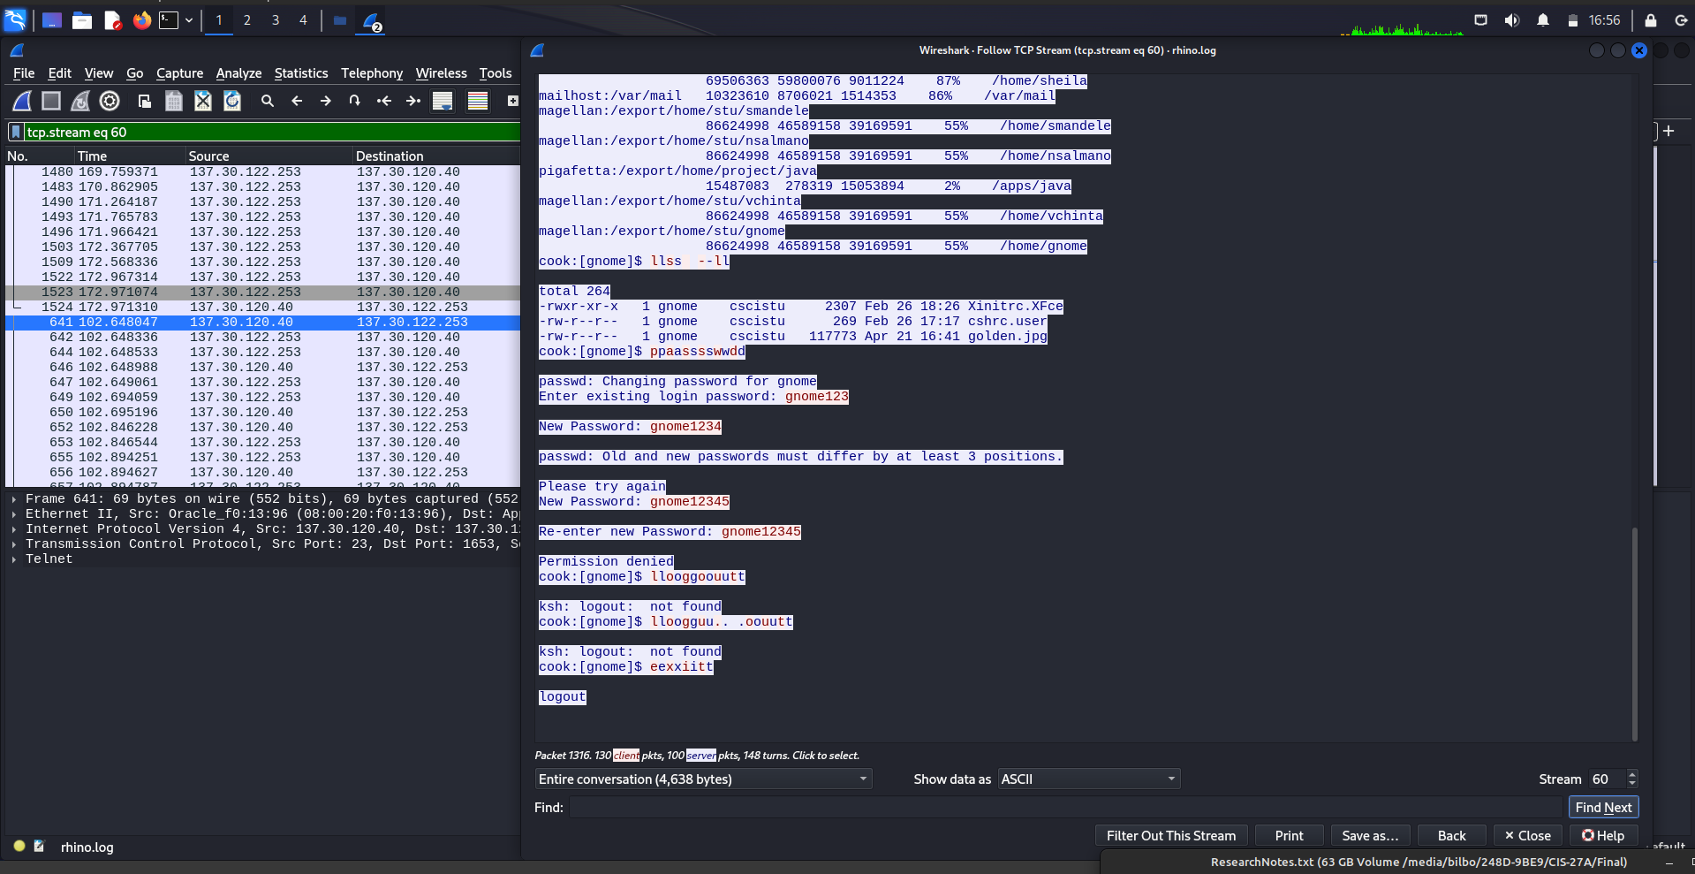

**Screenshot 16:** Screenshot from 2023-12-12 14-51-28.png

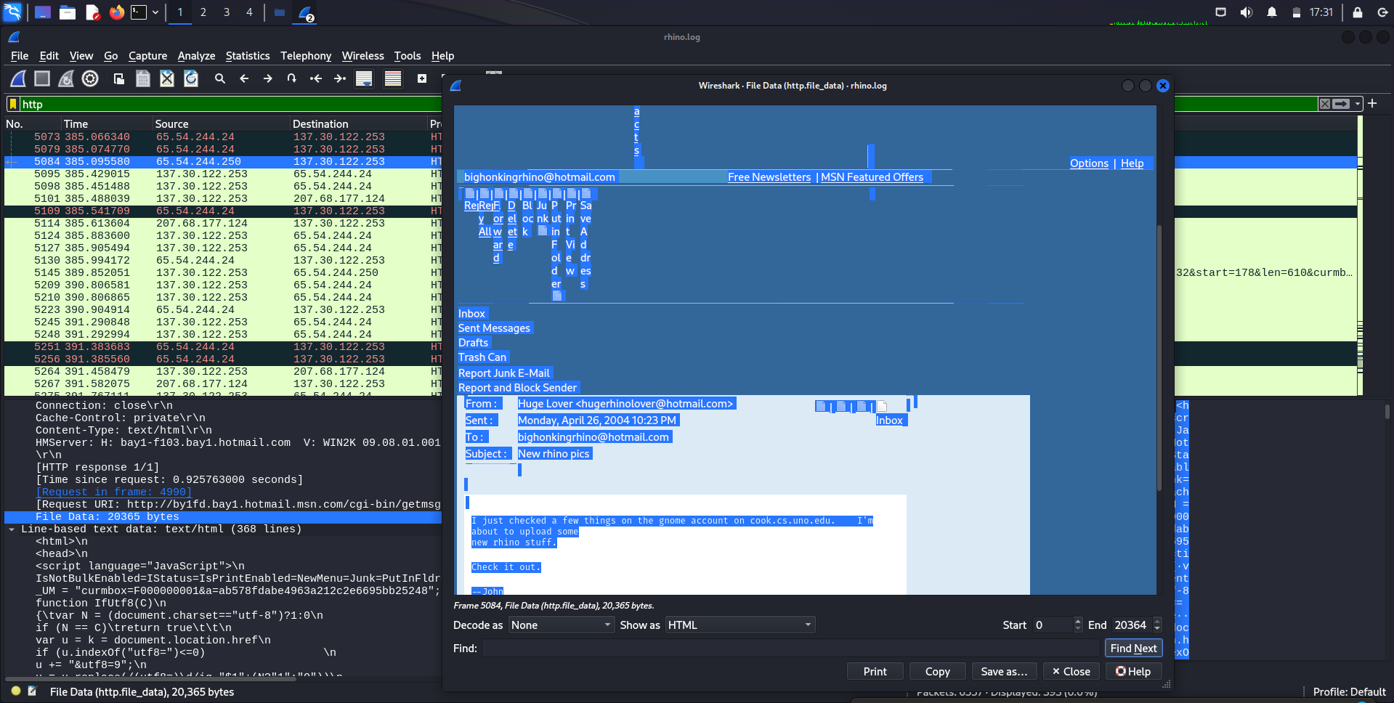

**Screenshot 17:** Screenshot from 2023-12-13 17-01-36.png

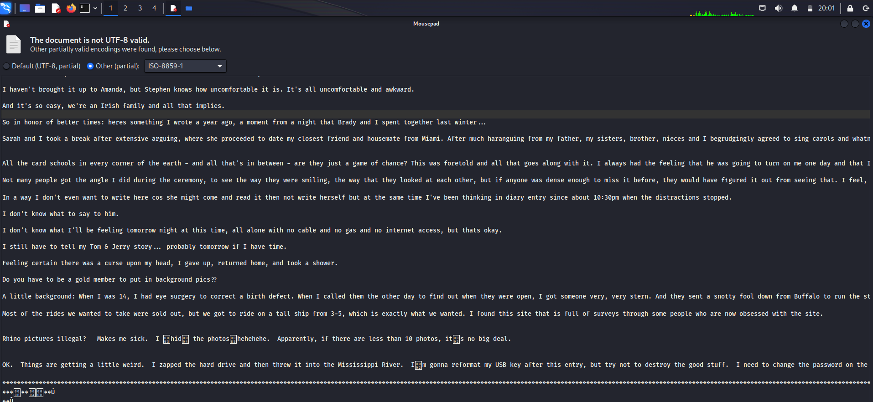

**Screenshot 18:** Screenshot from 2023-12-13 17-02-03.png

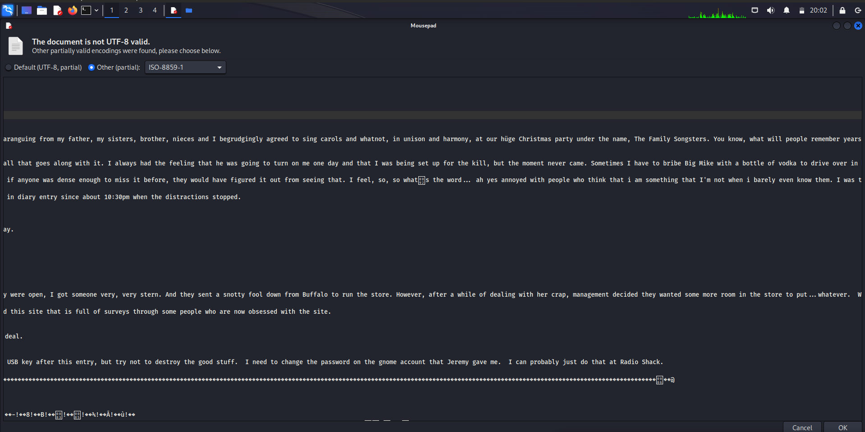

**Screenshot 19:** Screenshot from 2023-12-13 19-04-10.png

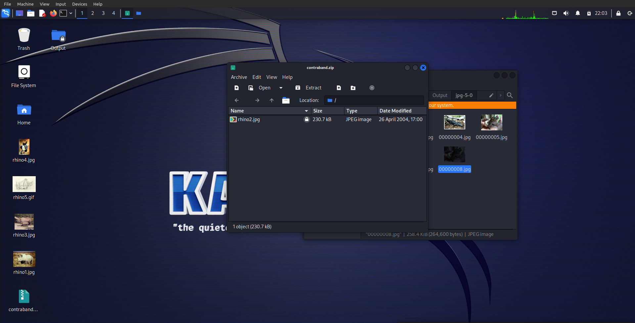

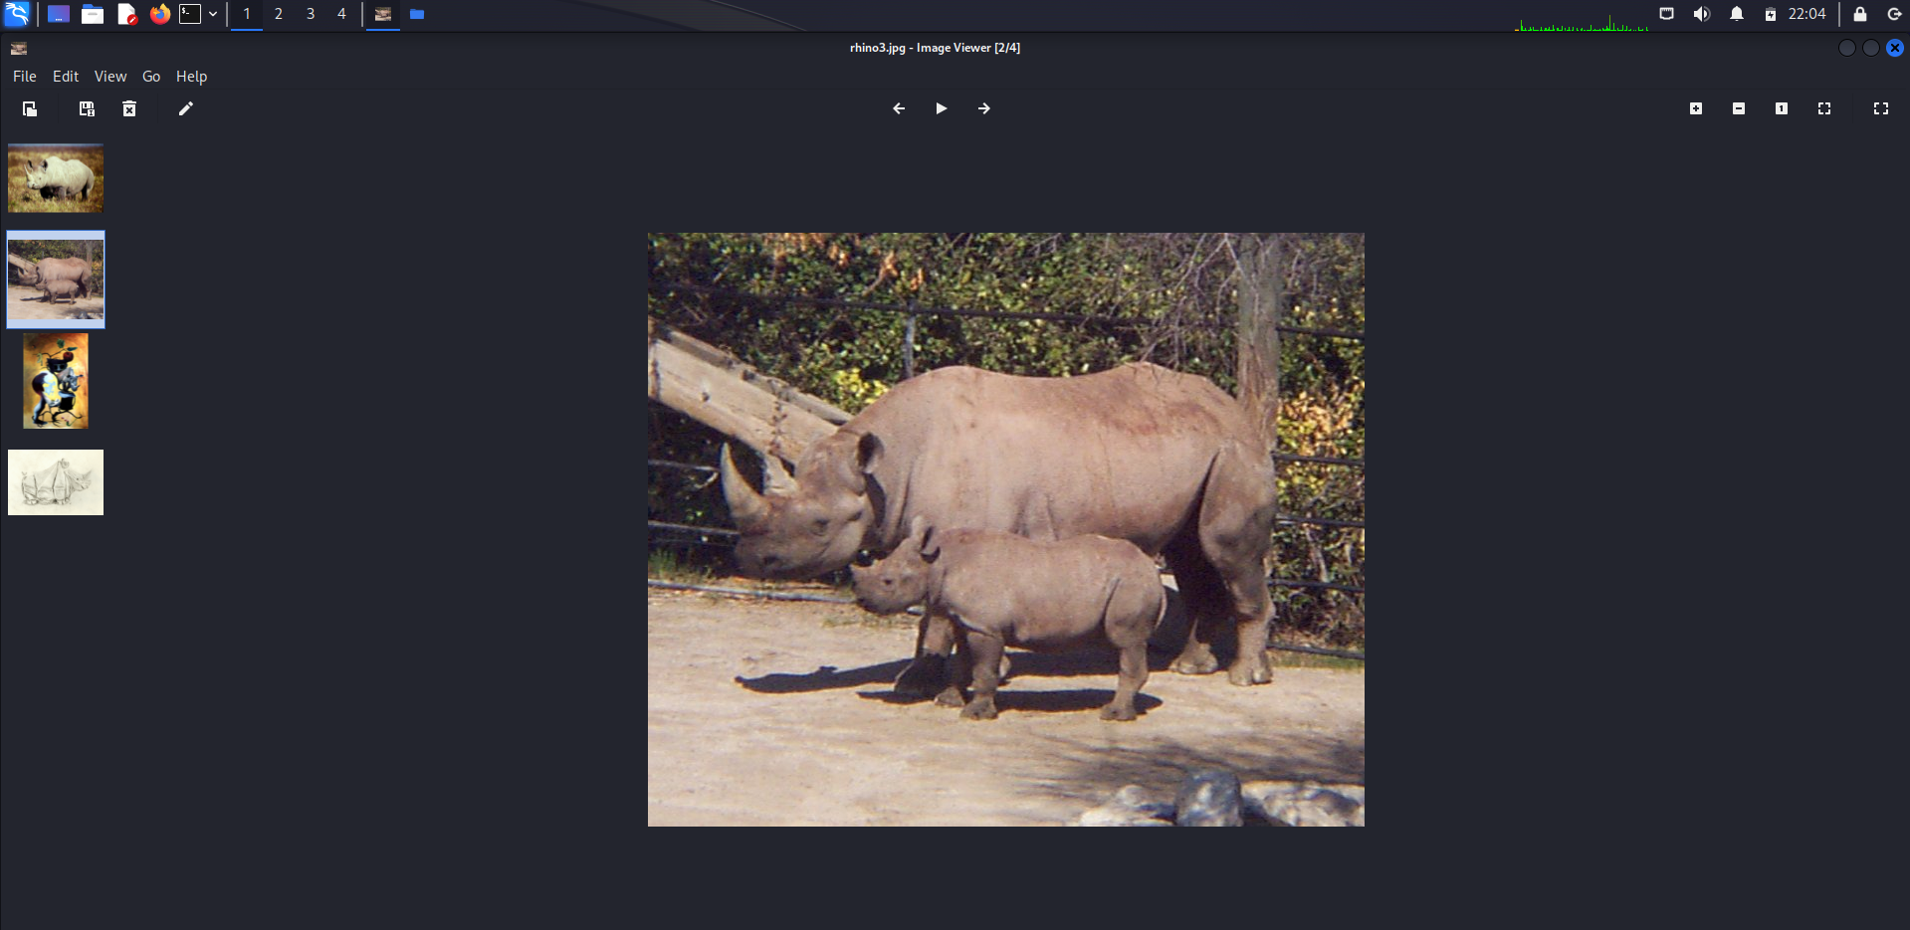**Screenshot 20:** Screenshot from 2023-12-13 19-05-02.png

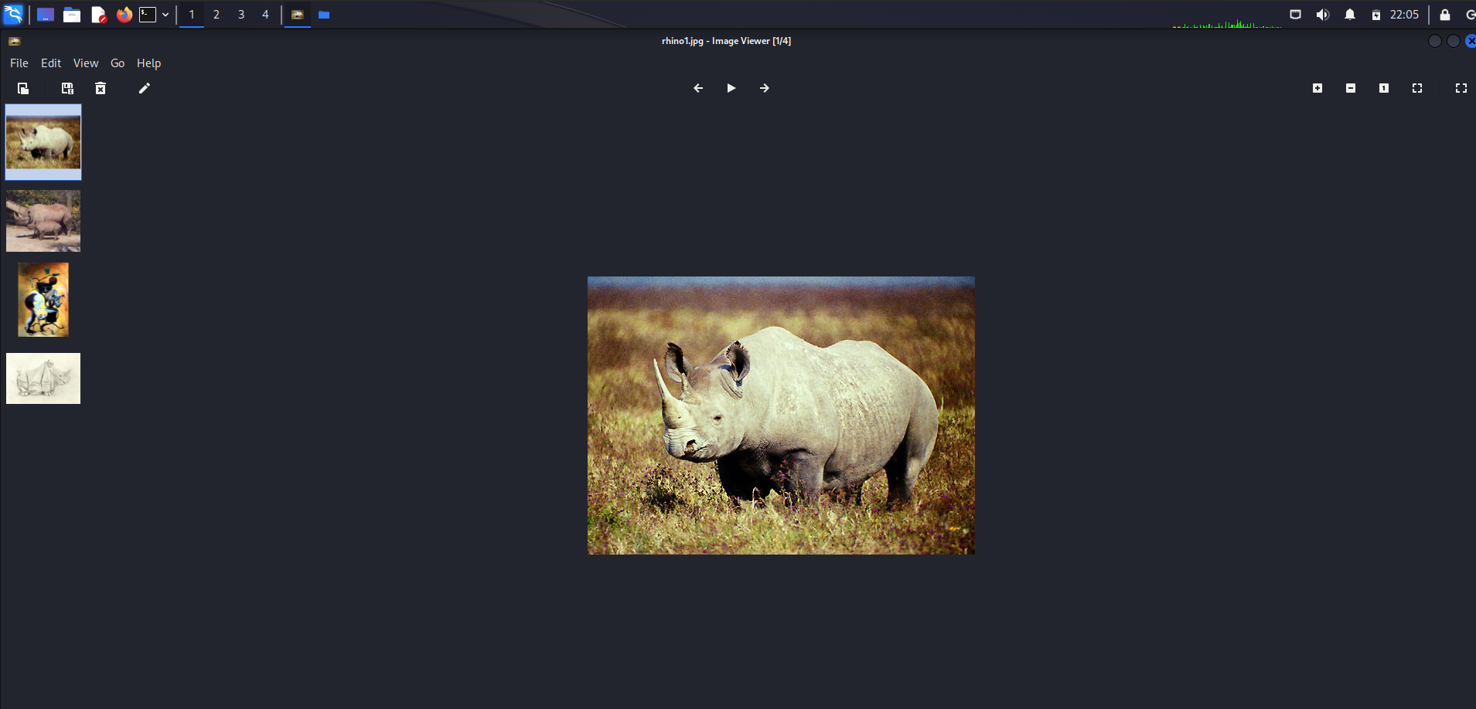**Screenshot 21:** Screenshot from 2023-12-13 19-05-28.png